
lab 7
Submitted to: Mr.Ali Hamza

October 6, 2023
22f-3327 RAFAY
BCS 3C

Q1
Logic 2
org 0x0100
jmp start

input_num dw 10 ; Input number for which to calculate the factorial
result dd 1 ; Result of the factorial calculation
temporary dd 1 ; Temporary storage for intermediate results

; Subroutine for swapping two values
swap_values:
push bp ; Save the base pointer
mov bp, sp ; Set up a new base pointer
push ax ; Save registers
push bx

mov ax, [bp + 4] ; Load the first value (ax)
mov bx, [bp + 6] ; Load the second value (bx)
mov [bp + 4], bx ; Store the second value in the first location
mov [bp + 6], ax ; Store the first value in the second location

pop bx ; Restore registers
pop ax
pop bp
ret 4
calculate_factorial:

push bp
mov bp, sp
push ax ; Save registers
push bx
push cx
push si

mov ax, [bp + 6] ; Load the input number (n) into ax
mov bx, [bp + 4] ; Load the result (initially 1) into bx

loop_outer:
mov cx, bx ; Copy bx to cx for inner loop

loop_inner:
cmp cx, 0
je next_iteration
mov si, [temporary]; Load the value from temporary into si
add [result], si ; Add si to the result
mov si, [temporary + 2]; Load the carry value from temporary into si
adc [result + 2], si; Add si to the upper part of the result
dec cx ; Decrement cx
jmp loop_inner ; Repeat the inner loop

next_iteration:
mov si, [result] ; Load the result into si
mov [temporary], si ; Store the lower part of the result in temporary
mov si, [result + 2]; Load the upper part of the result into si
mov [temporary + 2], si; Store the upper part of the result in temporary
inc bx ; Increment bx (n)
cmp bx, ax ; Compare n (bx) to the input number (ax)
jl loop_outer ; If n is less than the input number, repeat the outer loop

pop si ; Restore registers
pop cx
pop bx
pop bx
pop ax

ret 4 ; Return, popping 4 bytes from the stack

start:
mov ax, [input_num] ; Load the input number into ax
push ax ; Push it onto the stack
cmp ax, 1 ; If ax (NUMBER )is 1, exit the program
je exit_program
mov ax, 0
push ax
call calculate_factorial ; Call the factorial calculation routine

exit_program:
mov ax, 0x4c00
int 0x21

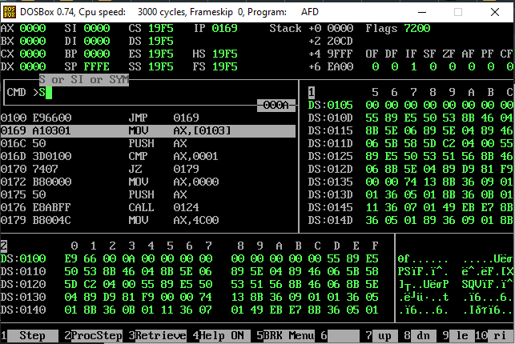
LOGIC 1(Not working )

[org 0x0100]

jmp start

factorial:

push bp ; save old value of bp

mov bp, sp ; make bp our reference point

push ax ; save old value of ax

push bx ; save old value of bx

push cx ; save old value of cx

mov cx, [bp+4] ; load the number from the stack

mov ax, 1 ; initialize the result to 1

mov bx, 1 ; initialize the multiplier to 1

loop_start:

cmp cx, 1 ; check if cx is equal to 1

je loop_end ; if yes, skip the multiplication

add ax, bx ; add bx to ax

inc bx ; increment bx for the next multiplication

dec cx ; decrement cx

jmp loop_start ; repeat the loop

loop_end:

pop cx ; restore old value of cx

pop bx ; restore old value of bx

pop ax ; restore old value of ax

pop bp ; restore old value of bp

ret 2 ; remove the parameter from the stack and return

start:

mov ax, 10 ; the number for which factorial is calculated

push ax ; place the number on the stack

call factorial ; call the factorial subroutine

mov ax, 0x4c00 ; terminate program

int 0x21

Q2
[org 0x0100]
jmp start

array1: dw 80, -7, -2, 45, 81, 50, 10, 9, 30, 99, 0
array2: dw 70, 32, 21, -3, -1, 31, 44, -9, 32

bubblesort:
push bp ; save old value of bp
mov bp, sp ; make bp our reference point
push ax ; save old value of ax
push bx ; save old value of bx
push cx ; save old value of cx
push si ; save old value of si

mov bx, [bp+6] ; load start of array in bx
mov cx, [bp+4] ; load count of elements in cx
dec cx ; last element not compared
shl cx, 1 ; turn into byte count

mainloop:
mov si, 0 ; initialize array index to zero
mov byte [bp-2], 0 ; reset swap flag to no swaps

innerloop:
mov ax, [bx+si] ; load number in ax
cmp ax, [bx+si+2] ; compare with next number
jbe noswap ; no swap if already in order

; Swap the numbers
xchg ax, [bx+si+2] ; exchange ax with second number
mov [bx+si], ax ; store second number in first
mov byte [bp-2], 1 ; flag that a swap has been done

noswap:
add si, 2 ; advance si to next index
cmp si, cx ; are we at the last index
jne innerloop ; if not, compare the next two elements

cmp byte [bp-2], 1 ; check if a swap has been done
je mainloop ; if yes, make another pass

pop si ; restore old value of si
pop cx ; restore old value of cx
pop bx ; restore old value of bx
pop ax ; restore old value of ax
pop bp ; restore old value of bp
ret 4 ; go back and remove two parameters from the stack

start:
mov ax, array1 ; start of array1
push ax ; place start of array1 on the stack
mov ax, 10 ; element count for array1
push ax ; place element count on the stack
call bubblesort ; call the bubblesort subroutine

mov ax, array2 ; start of array2
push ax ; place start of array2 on the stack
mov ax, 9 ; element count for array2
push ax ; place element count on the stack
call bubblesort ; call the bubblesort subroutine

; Clear the stack
add sp, 4

mov ax, 0x4c00 ; terminate program
int 0x21


